Work Instruction for Lighting Maintenance

Objective:
- Light fixture/ supply outlet Removal ,repairs and installation,
- LDB/ supply outlet replacement.

Scope: All over the plant.

Ref: Nil

- Aspect: Waste generation,
- Impact: Resource depletion
- Hazards: Physical-Electrical shock , Mechanical-Falling, and Ergonomics-improper design tools
Behavioural Hazard:Non adherence to SOP.
Responsibility: Contractor Employee, contractor supervisor, company Electrician

- Take proper electrical shutdown like disconnection of supply wires at the source before
taking up the job on light fitting. LOTO has to be used wherever working by switching
off MCB

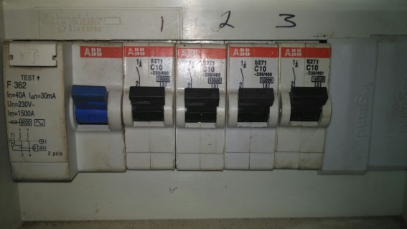
- Ensure the ladder which is used for the job is certified, safe & has got Rubber pad at the bottom.
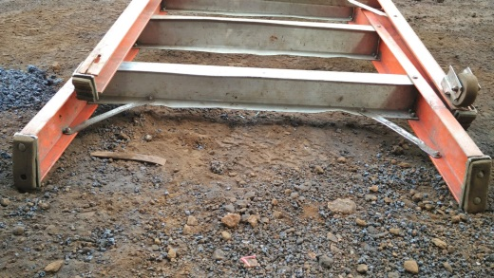

- Use safety harness as per IS 3521 while working at height.
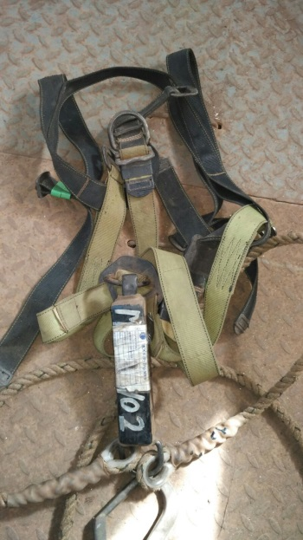
- Disconnect and remove the fitting down.
- Overhaul and test it in electrical workshop
- Fix back the fitting and give connection with proper glanding and termination.
- Tube light fixture mounting on a wall or on a concrete ceiling has to be done only on a anchor fasteners. Reflector of tube light has to be mounted on fixture with nut bolt arrangements to avoid fall of reflector
- In case of fixing of tube light fixtures on a wooden ceiling, light fitting has to be fitted with nut bolt system fitted to a wooden ceiling.
- Ensure every fitting and gearbox is earthed.
- Ensure that there is no joint for the cable in between
- No luminaries are attended at site above three-meter height. All repairs shall be carried
out at workshop.It shall ensured that the lamp replacement is carried out by putting off the supply.
- In case of blower house and TG house, lights will be repaired with the help of monorail crane and by using safety belt. Ensure that one person is there down to see that nobody moves the crane when a workmen employee is carrying out the repair job on top.
- Ensure that the persons working at height are conversant with the work instructions related to the activity.
- Inspect & ensure that the safety belt is safe for the use. Only IS approved/Certified belts shall be used.
- Ensure that the belt is tide to a rigid and strong structure which can take the weight of a person if he falls. Avoid tying to angle less than 50mm. Anchoring hook shall not slide on a structure to which it is tied.
- Use the ladder on stable and level surface.
- Do not shift or move the ladder while in use.
- Always face the ladder while climbing up or down. Used both hands and maintain a secure grip and three point contact
- Climb first and then pull up the material.
- Used portable/step ladders to carry out the lighting job such as lamp replacement, cable dressing etc. Ensure that maximum height should not exceed 3mts. For height exceeding 3mts. use step ladders with platform and cage that is attending to street light fittings
- Don't use stepladders for attending lighting jobs on pole.HIAB has to be used for attending lighting jobs at lighting poles/ street light poles.
- A light fixture has to be fitted on a standard MS angle bracket welded to the main structure with a nut bolt arrangement. No fitting shall be mounted / tied with wire or wound with loose clamp.
- Never install a light fitting on crane LT girder as it is likely to expose for vibration and thus its accessories like glass, relector, bulb may get loosened and fall down.
- High mast towers auto switching to be checked during maintenance for fuctioning. to avoid human intervension for switching.
- Highmast towers doors locking to be checked to avoid unathorised access to starter panel.

LDB REPLACEMENT
- Takeshutdown of the respective lighting DB. Ensure both phase and neutral is isolated at the source side.
Responsibility: Engineer and Electrician
- For proper MCB co-ordination ensure that, for three phase lighting DB incoming MCB/RCBO rating is 4 pole 63 amps, 30 mA sensitivity & outgoing MCB rating is 32 amps, and for single phase lighting DB incoming MCB /RCBO rating is 32 amps, 30 mA sensitivity & out going MCB rating is 20 amps or below depending on the load.
Responsibility: Electrician
- Every lighting DB has been provided with 30 MA sensitivity ELCB protection either directly or through the main DB supplying this sub DB.
Responsibility: Electrician
- Every DB is to be provided with the earthing continuity either through the spare core or by laying separate conductor from the main source feeder.
Responsibility: Electrician
- Spare opening is to be sealed with the blanking plates to avoid dust entry.
Responsibility: Electrician
- Spare cores of incoming and outgoing cables are to be kept dead and properly insulated at both the ends.
Responsibility: Electrician
- Every DB has to marked with serial number along with information on incoming and outgoing supply details.
Responsibility: Electrician
- Lighting DB's which are exposed to the water are to be covered with the canopy for protection.
Responsibility: Electrician
- During preventive maintenance LDB, Functioning of the RCCB is to be tested for tripping as well as the rating of the MCB's/RCBO as stated above.
Responsibility: Electrician
- DB maintenance will be carried out strictly as per the preventive maintenance check list.
Responsibility: Electrician
- New LDB installation or replacement of LDB will be cross checked for proper installation by the concerned Engineer In-charge and shall be taken into maintenance list for carrying out periodic maintenance.
- If any lighting DB, Light fitting, Supply outlet board has to be removed for temporary/ permanent durations, ensure that the supply cable is kept disconnected at the main supply source. No cables shall be left one ended open with other side connected even the switch/ MCB is kept off.
Responsibility: Area Engineer

Note: No power Circuit to be kept remain charged with faulty RCCB . In no case RCCB can be bypassed.

Amendement Record
Date | Manual Section Ref. & Para | Brief details of Revision | New Rev.

Prepared By:  Senior Elect. Engineer | Reviewed & Issued By:  Management Representative | Approved By:  Head – Electrical & Instrumentation PID I
Signature | Signature: | Signature:
Review Date: 04.03.2023 | Review Date: 04.03.2023 | Review Date: 04.03.2023

